Babe Ruth Firecracker Camping Availability

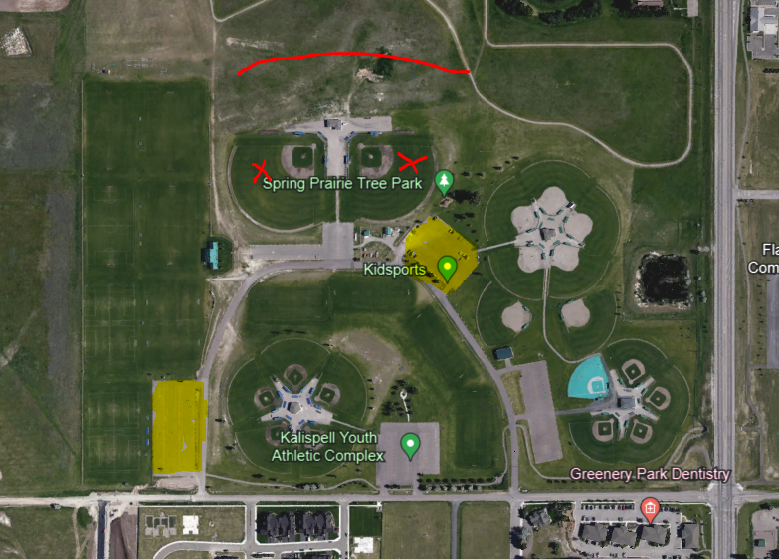

Red X – Kalispell Babe Ruth Fields
Yellow Highlighted Parking lots – Available Camping
Red line behind fields- New Lacrosse fields and parking lot have been built. We are uncertain if there will be tournaments that weekend. If not the parking lot is available for camping.

